

**Name:** Joseph MUTANGANA

**Student ID:** 29061

**Course Name:** Computer Networks

**Assignment Title:** Assignment#0

**Date:** Sep-14-2025

**Statement:**  I, Joseph MUTANGANA, confirm that results on this report is my own, and I understand that violating academic and course integrity results punishments.

Table of Contents

**Task A – DoD (TCP/IP) vs OSI model** 2

**Task B – TCP vs UDP** 3

**Task C – Module-by-Module Reflection (17 modules)** 4

**Task D – Network Topologies** 9

**Task E – Installation evidence** 11

**Task F - Networking Basic course evidence** 11

**Task G – Agreements & Commitment Plan** 12

**Appendices** 12

# 

# **Task A – DoD (TCP/IP) vs OSI model**

**a) DoD (TCP/IP) Model – Four Layer**

**Application Layer (DoD):**

|  |  |  |  |
| --- | --- | --- | --- |
| **Layer** | **Responsibilities** | **Typical Protocols** | **Example Scenario** |
| **Application** | Provide user interface | HTTP, HTTPs,DNs | Browser request a website using HTTP |
| **Transport** | Ensures end-to-end Communication | TCP,UDP | TCP used for downloading a file reliably |
| **Internet** | Logical addressing & routing | IP, ARP,IPv6 | Router forward a packets based on destination IP address |
| **Network Access/Link** | Frames & MAC addressing | Ethernet, Wi-Fi, ARP | PC send Ethernet frame via switch using MAC address |

**b) Compare DoD vs OSI – structural & functionality differences**

|  |  |  |  |
| --- | --- | --- | --- |
| **No** | **OSI 7 Layer** | **TCP (DoD) 4 Layer** | **Main Responsibilities** |
| 7 | Application | Application | App service like HTTP,DNS |
| 6 | Presentation | Data format |
| 5 | Session | Session Management |
| 4 | Transport | Transport | Reliable delivery, error recovery |
| 3 | Network | Internet | Routing, IP addressing |
| 2 | Data Link | Network Access | MAC addressing, frame delivery |
| 1 | Physical | Electrical, media |

**c) Inclusions per layer**

**Application:**

* DNSresolves domain IP
* HTTPfetches web content

**Transport:**

* TCP ensures reliable delivery
* UDP used for fast, real –time delivery

**Network / Internet:**

* IP provides logical addressing
* ARP maps IP -> MAC for delivery

**Data Link / Network Access**

* Ethernet transmits frames
* Wi-fi sends data wirelessly
* MAC address used for local delivery

**d) OSI Model in Depth (7 layers with real-life examples)**

|  |  |  |  |  |
| --- | --- | --- | --- | --- |
| **No** | **Layer** | **Definition** | **Protocol** | **Example** |
| 7 | Application | This is Layer that provide user-level services | HTTP, FTP. DNS | Browser shows web page |
| 6 | Presentation | Layer that handles data encoding & encryptions | TLS, compression | HTTP encrypts the page |
| 5 | Session | It is layer that start and ends sessions | RDP, NetBIOS | RDP login to remote system |
| 4 | Transport | Layer that handles reliable/unreliable delivery | TCP/UDP | TCP download resume after drop |
| 3 | Network | Routing across networks | IP, Routers | Router forwards packet to next hop |
| 2 | Data Link | MAC & frame delivery | MAC, switches, frames | Switch uses MAC to forward frame |
| 1 | Physical | Media transmission | Wireless, Cables, bits, NICs | Copper cable transmits binary pulses |

Diagram shows how data moves from sender to receiver

# **Task B – TCP vs UDP**

**a) Transmission Control Protocol (TCP)**

* Connection (3-way handshake)
* Reliable delivery
* Flow control (sliding window)
* Congestion control (slow start)
* Ordered data transfer

**b) User Datagram Protocol (UDP)**

* Connectionless
* No retransmission
* Low latency, small overhead
* Stateless, no sequencing

**c) TCP vs UDB Table**

|  |  |  |
| --- | --- | --- |
| **Feature** | **Transmission Control (TCP)** | **User datagram protocol (UDP)** |
| Reliability | Yes | No |
| Ordering | Yes | No |
| Overhead | High | Low |
| Latency | Higher | Low |
| Use cases | Emails, Web | Streaming, DNS |
| Handshake | Yes | No |
| Error handling | Built-in | Handled by application |

# **Task C – Module-by-Module Reflection (17 modules)**

Module 1: Communication in a connected world

a) Observation

In network types, I saw that Internet is not owned by an individual or group, but is worldwide.

In data transmission, I saw categories of personal data such as Volunteered data, Observed data, and inferred data

In Bandwidth and Throughput, I saw that bandwidth is measurement of amount of data that flow from one place to another.

While Throughput measures all data being sent and received including latency/delay of data flows from one place to another.

b) Real World example

Transferring file between devices like two phones, then phone A is about to send music file to phone B with specific amount of that file. Bandwidth will track how much amount of file/Kbps is being transferred from A to B in seconds.

c) one question or idea

Why do we need to connect the world?

d) Key takeaway

* Internet is not physical connection in real world. It is the place people go to find or share information.
* Internet is not owned by an individual or a group. It is worldwide collection of interconnected networks
* Bandwidth is measurement of amount of data flows from one place to another.
* Throughput is measurement of amount of data between one to another including delays.

Module 2: Network Components, Types and Connections

a) Observation

In Clients and Servers, I saw that computers connected to a network that participates directly in a network communication are classified as host. The software installed on computer determines which role the computer will plays. Client can work as server and server work as client that called peer-to-peer network.

In Network components, I saw that the network infrastructure has three categories such as End devices, intermediary devices, and network devices.

ISP Connectivity Option, An ISP provides the link between the home network and the internet.

b) Real World example

Network components used in many places such as home, offices, schools, etc. At home I may use my phone, Television, and Router also at office they make network and connect to internet by using network components

c) one question or idea

d) Key takeaway

* Different between server and client
* Definition of peer-to-peer network
* ISP provides the link between network and the internet
* DSL (Digital Subscriber Line

Module 3: Wireless and Mobile Networks

a) Observation

b) Real World example

c) one question or idea

d) Key takeaway

Module 4: Build Home Networks

a) Core Concept:

b) What I observed

c) Real World example

d) one question or idea

e) Key takeaway

Module 5: Communication Principles

a) Core Concept:

b) What I observed

c) Real World example

d) one question or idea

e) Key takeaway

Module 6: Network Media

a) Core Concept:

b) What I observed

c) Real World example

d) one question or idea

e) Key takeaway

Module 7: The Access Layer

a) Core Concept:

b) What I observed

c) Real World example

d) one question or idea

e) Key takeaway

Module 8: The Internet Protocol

a) Core Concept:

b) What I observed

c) Real World example

d) one question or idea

e) Key takeaway

Module 9: IPv4 and Network Segmentation

a) Core Concept:

b) What I observed

c) Real World example

d) one question or idea

e) Key takeaway

Module 10: IPv6 Addressing Formats and Rules

a) Core Concept:

b) What I observed

c) Real World example

d) one question or idea

e) Key takeaway

Module 11: Dynamic Addressing with DHCP

a) Core Concept:

b) What I observed

c) Real World example

d) one question or idea

e) Key takeaway

Module 12: Gateway to Other Networks

a) Core Concept:

b) What I observed

c) Real World example

d) one question or idea

e) Key takeaway

Module 13: The ARP Process

a) Core Concept:

b) What I observed

c) Real World example

d) one question or idea

e) Key takeaway

Module 14: Routing Between Networks

a) Core Concept:

b) What I observed

c) Real World example

d) one question or idea

e) Key takeaway

Module 15: TCP and UDP

a) Core Concept:

b) What I observed

c) Real World example

d) one question or idea

e) Key takeaway

Module 16: Application Layer Services

a) Core Concept:

b) What I observed

c) Real World example

d) one question or idea

e) Key takeaway

Module 17: Network Testing Utilities

a) Core Concept:

b) What I observed

c) Real World example

d) one question or idea

e) Key takeaway

# **Task D – Network Topologies**

**Bus:** A single central cable connects all devices in the network,

**Diagram**

Device 1

Device 2

Device 3

Device 6

Device 4

Device 5

**How it operates:** All nodes are connected to one shared communication line

Real World uses and examples

**Advantages**

* Simple and inexpensive layout
* Requires less cable than star or mesh
* Easy to extend with minima changes

**Disadvantages**

* If the main cable fails, the whole network fails
* Limited scalability and speed
* Difficulty to troubleshoot

**Recommendation:**  Only use in very small or temporary setups.

**Ring:**  Each device connects exactly two others, forming a ring

**Diagram**

**How it operates:**  Data passes from one device to the next, unit it reaches its destination

**Advantages**

* Equal access for all nodes
* Predictable performance under load
* Can prevent collisions

**Disadvantages**

* A single point of failure
* Difficulty to add/remove nodes
* Higher latency with more devices

**Observation**

**Recommendation**: Best for telecom using fiber ring for high redundancy

**Mesh:**  Devices are interconnected, allowing multiple paths between any two devices.

**Two types of mesh**

**Full-mesh:** Every node connected to every other.

**Partial-mesh:** Some nodes have multiple connections, other fewer

**How it operates:** Multiple links ensure continuous communication even if one link fails

**Real World uses and example:** ISP, data centers, and cloud providers use mesh for resilience

**Advantages**

* High Fault tolerance
* Multiple redundancy paths
* Supports heavy traffic well

**Disadvantages**

* Complex and expensive
* Requires lots of cabling and configuration
* Harder to manage and scale in physical networks

**Star:** All devices connect to a central hub/switch

**Diagram**

**How it operates:** Devices send data to central node, it forwards to destination.

Real World uses and examples

**Advantages**

* Easy to manage
* Simple to add/remove devices
* Centralized monitoring

**Disadvantages**

* Central devices is a single point of failure
* High cable use
* Not cost-effective for large areas

**Hybrid:**  A combination of two or more topologies

**Diagram**

**How it operates:** Different segments use topologies suited to their purpose.

**Advantages**

* Flexible and scalable.
* Can optimize cost and performance per segments
* Fault isolation possible in segments

**Disadvantages**

* Design can be complex
* Troubleshooting requires understanding of multiple topologies
* May be costlier to maintain that pure designs

# **Task E – Installation evidence**

Packet Tracer

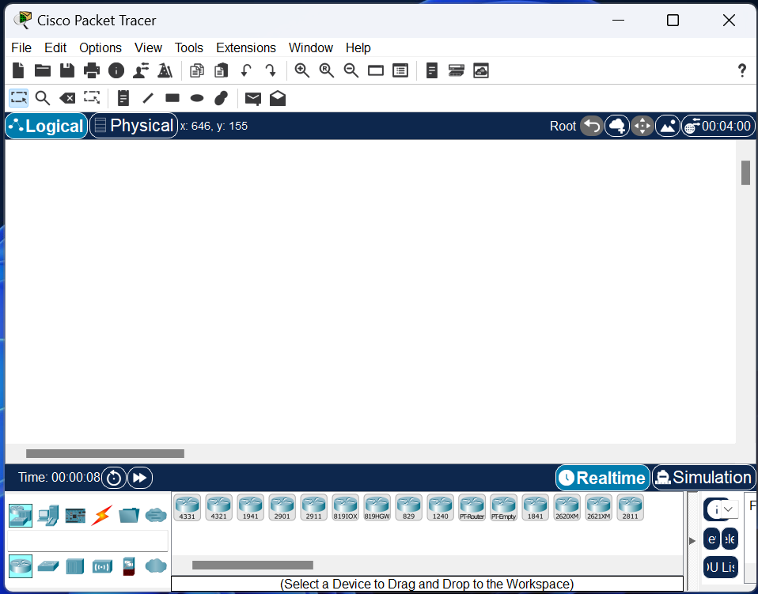

Virtual-Box

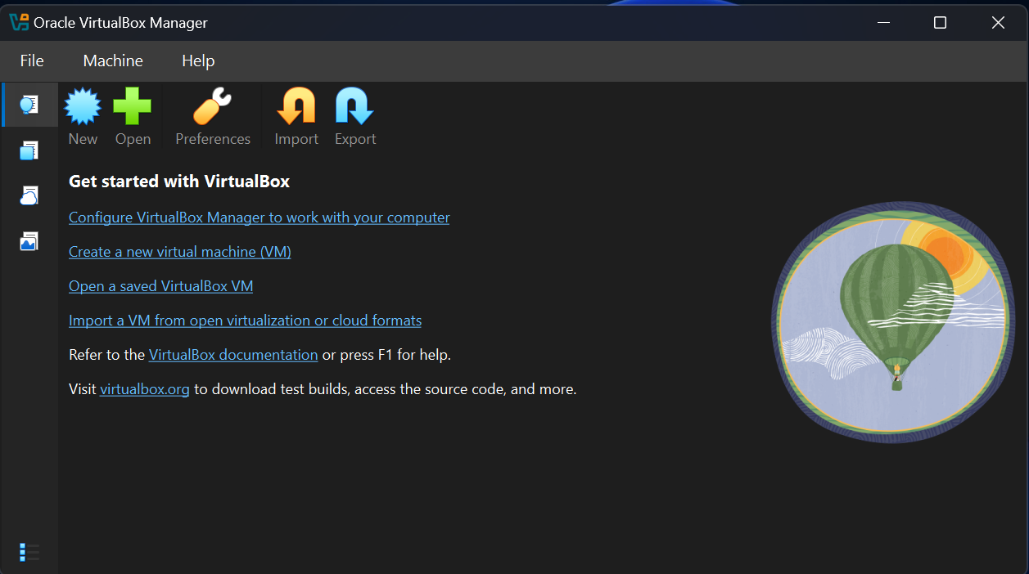

EVE-NG (Community Edition)

VMware Workstation Player / Pro

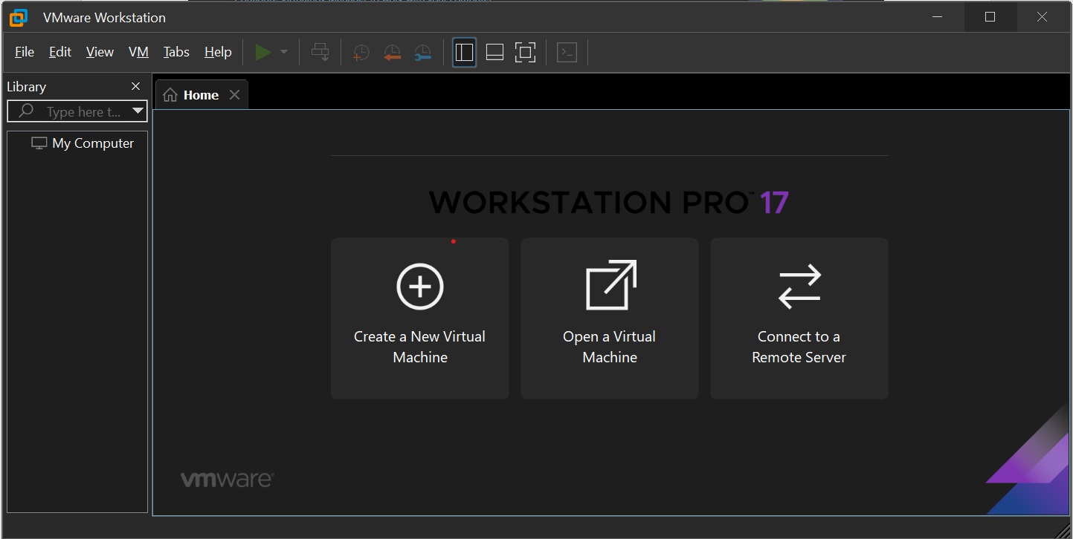

Computer Networks Course Enrollment on Canvas 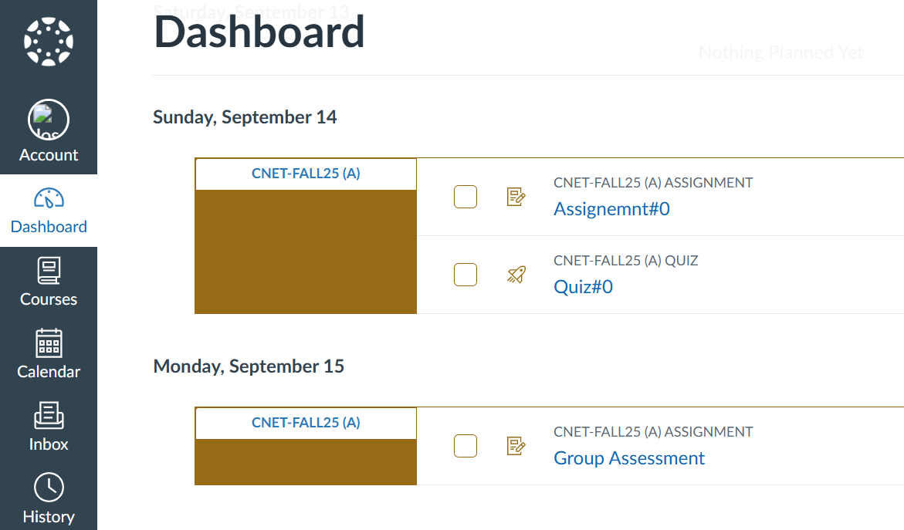

Canvas Profile

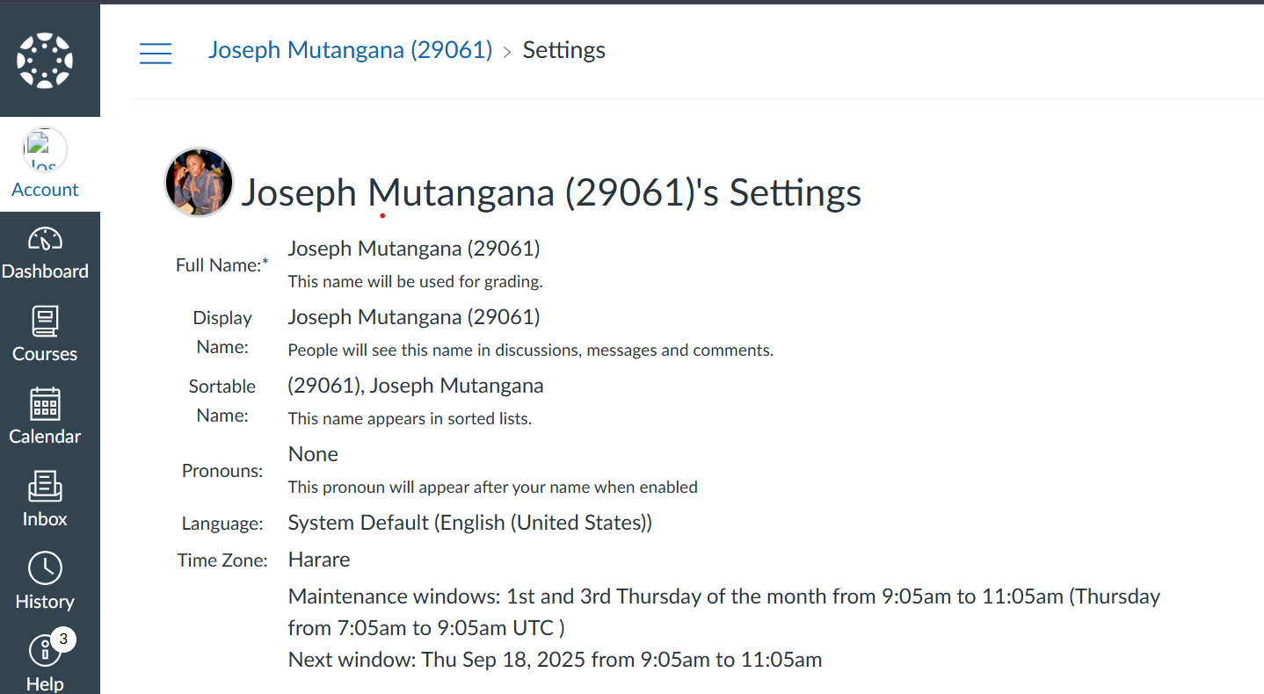

# **Task F - Networking Basic course evidence**

Course completion/grade page

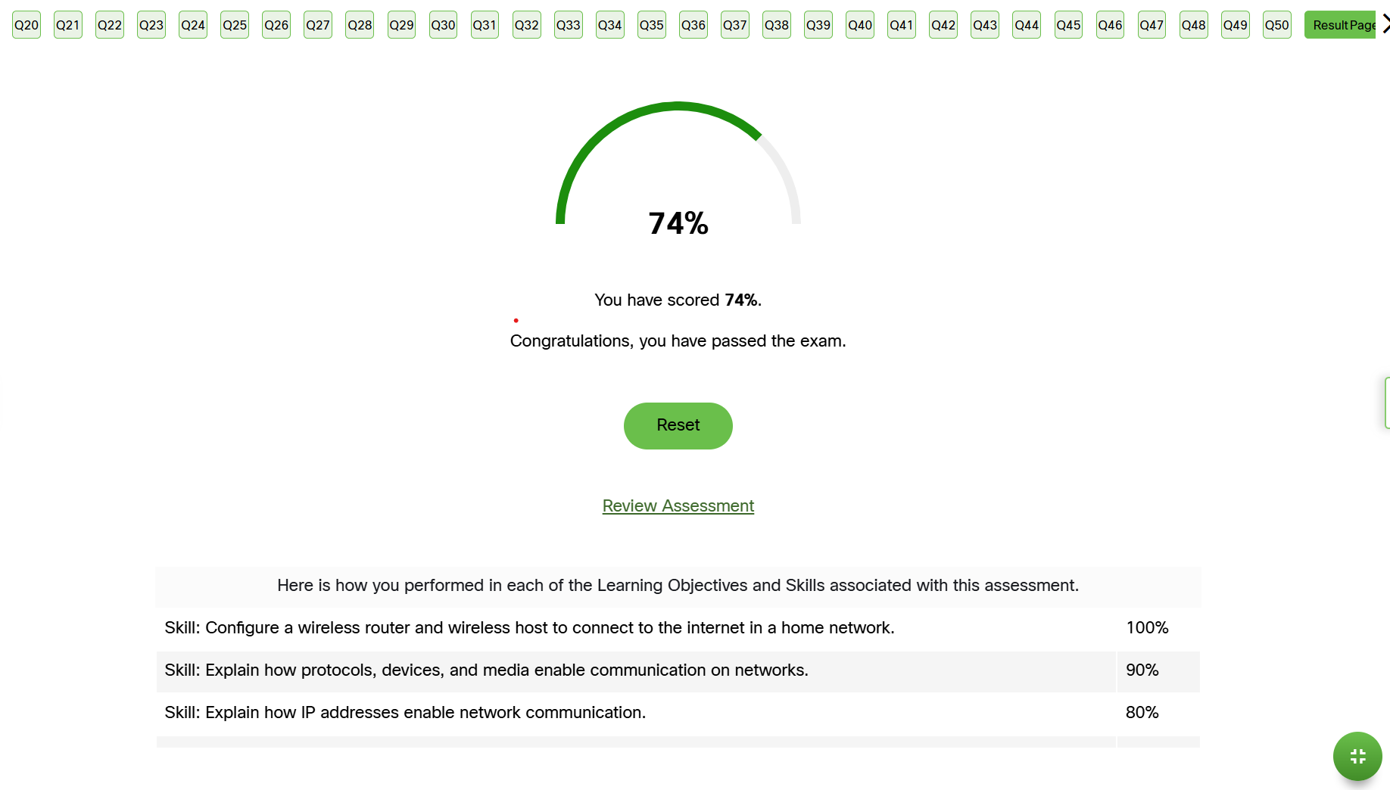

Networking Basics Badge on Cledly

<https://www.credly.com/users/mutangana-joseph>

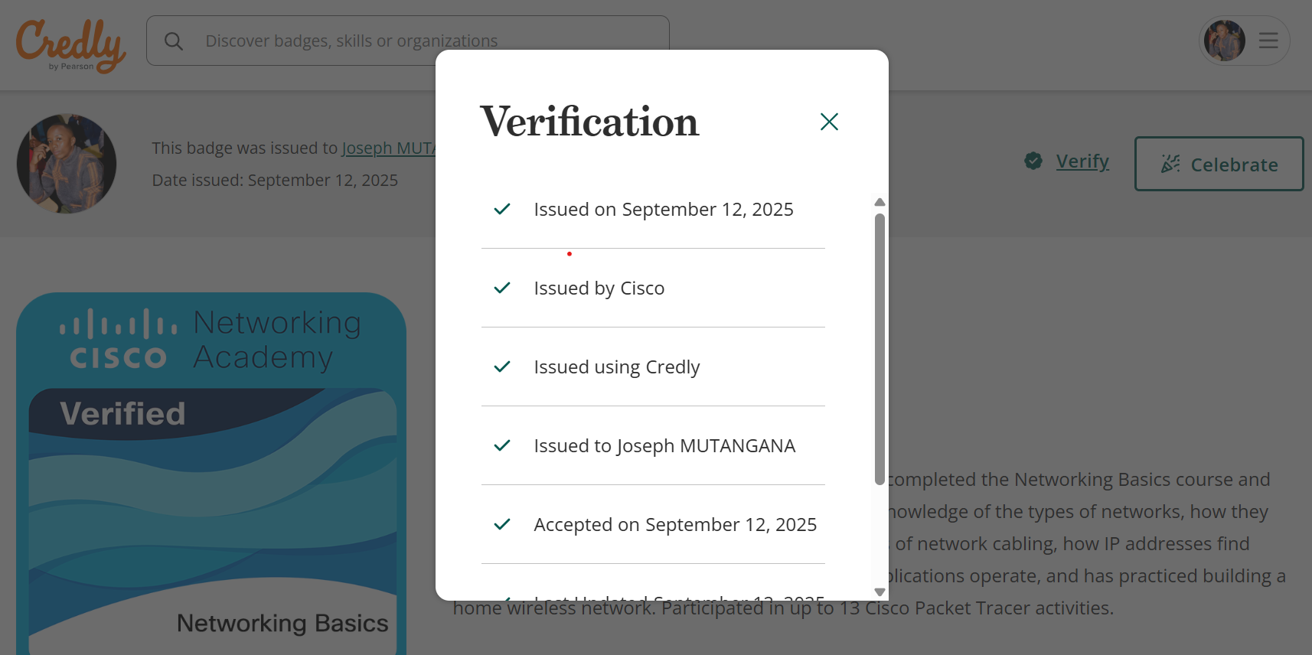

Networking Basics badge on Linkedin

[www.linkedin.com/in/mutangana-joseph](http://www.linkedin.com/in/mutangana-joseph)

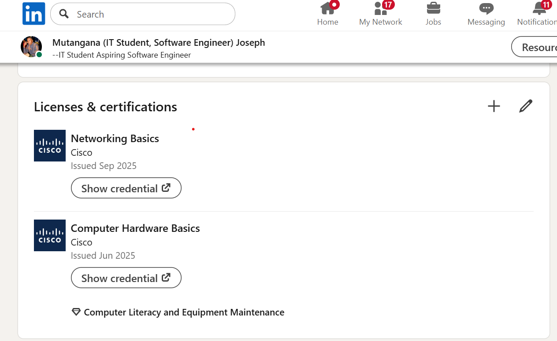

# **Task G – Agreements & Commitment Plan**

* I, Joseph MUTANGANA – 29061, commit to attend classes, participate actively, follow instructor directions, and complete assignments on time.
* I will maintain academic integrity: submit original work, cite sources, and avoid plagiarism.
* I will avoid distractions in class (like using phone or any unrelated activities).
* I understand consequences for violations (grade penalties, academic review) and accept them.



**Date:** 14/09/2025 **Signature:**

# **Appendices**

**References:**

<https://www.netacad.com/courses/networking-basics?courseLang=en-US>

<https://access.redhat.com/downloads/content/rhel>

<https://www.eve-ng.net/index.php/download/>

<https://www.virtualbox.org/wiki/Downloads>

<https://www.netacad.com/courses/packet-tracer>

<https://support.broadcom.com/group/ecx/productdownloads?subfamily=VMware%20Workstation%20Pro&freeDownloads=true>

<https://www.microsoft.com/en-us/download/details.aspx?id=23163>

<https://drive.google.com/drive/folders/1BXlAGxgTpcqxMHntGga48h8Ohf3H9JY9>